FXD Transaction Alloctaions

Objective

To allocate/un-allocate the following
Transactions
Attachments
Reports
To provide the following allocation modes
System
Role
User
To list transactions based on allocation

DB Design

New Framework Table
TRANSACTION_ALLOCATIONS
TA_ID
Primary Key column of the table
ITEM_ID
Transaction Set Id of the allocated transaction
PARENT_ITEM_ID
Transaction Attachment Id (If allocation is needed in attachment level)
ITEM_TYPE
Transaction
Attachment
Report
ALLOCATED_APP_STS_ID
Transaction allocated APP_STS_ID
ALLOCATED_APPU_ID
Transaction allocated APPU_ID
ALLOCATED_APPR_ID
Standard audit column
CREATED_BY
Standard audit column
CREATED_DATE
Standard audit column
Process

- A new handler code -

ALLOCATION

- Allocation can be done for single selected item only.
- It can be raise from any button or Context menu controls
  - Could be listen by
    - Treeview (or)
    - Listview

Ex: In Treeview Context Menu

- A new pop up window will be shown on this handler

Event Params for Allocation Window
Type of record
TRANSACTION
ATTACHMENT
RECORD
Mode of allocation
System
Role
User
  - This mode will be bind on top combo box.
  - Combo data order will be as given in the bahavior event param
  - Only needed mode can be given on event param.
Level of allocation
FULL
RESTRICTED
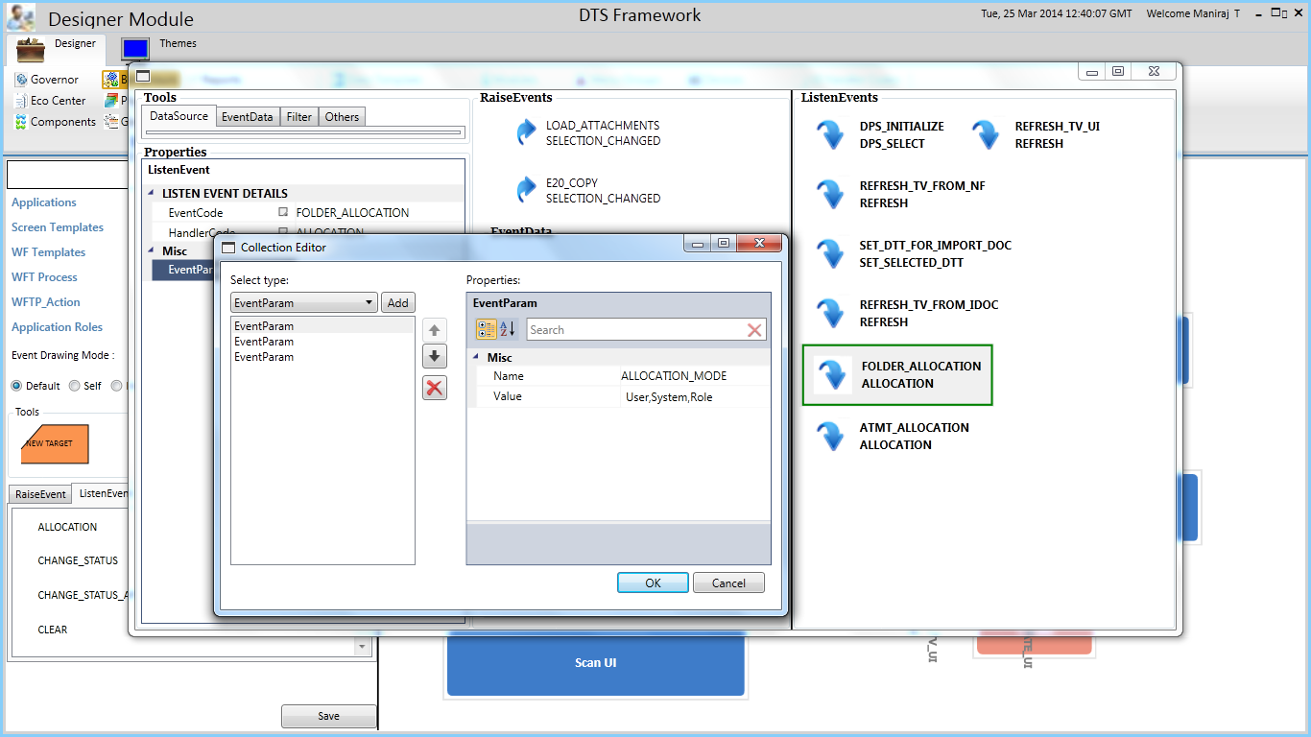

- its name should be ALLOCATION_MODE

- its name should be ALLOCATION_LEVEL
- Possible Values are
  - FULL
    - Will be show all the list of selected mode without any filter current user.
  - RESTRICTED
    - Will be show data with filter of current login User APPSTS_ID.

- its name should be ALLOCATION_TYPE
- Possible Values are
  - TRAN
  - ATMT
  - RPT

System View

- Already alloctaed item will be selected as above.
- To allocate/unallocate the item double click the tree node

Roles View

- Already alloctaed item checkboc will be marked as selected as given below:

Scripts for Listen Event Params

BHV_ATTRIB_MASTER
--------------------------------

insert into BHV_ATTRIB_MASTER (BHVAM_ID, BHVAM_CATEGORY, BHVAM_CODE, BHVAM_DESCRIPTION, PARENT_BHVAM_ID, BHVAM_VALUE, CREATED_BY, CREATED_DATE, MODIFIED_BY, MODIFIED_DATE, VERSION_NO, UIHC_ID, APP_ID)
values (1072, 'ATTRIBUTES', 'EVENTPARAM', null, 1071,
'<EVENT_PARAMS>
<EVENT_PARAM NAME="ALLOCATION_MODE" VALUE =""/>
<EVENT_PARAM NAME="ALLOCATION_LEVEL" VALUE =""/>
<EVENT_PARAM NAME="ALLOCATION_TYPE" VALUE =""/>
</EVENT_PARAMS>' ,
1, SYSDATE, null, null, 0, 0, 1);

UI_CONTROLS
------------

insert into UI_CONTROLS
(UICTRL_ID,
UICTRL_CODE,
UICTRL_DESCRIPTION,
UICTRL_TYPE,
PARENT_UICTRL_CODE,
ASSEMBLY_FULL_NAME,
HANDLED_EVENTS,
STYLE,
CREATED_BY,
CREATED_DATE,
MODIFIED_BY,
MODIFIED_DATE,
VERSION_NO,
NEED_DATA_SOURCE,
UICTRL_CATEGORY,
UICOM_TYPE,
RUNTIME_REFERENCE)
values
(15129,
'ALCTN_ROLES_LSV',
'Roles Listview',
'CHILD_COMPONENT',
'ALCTN_HNDLR',
null,
null,
'LSV_DIFF_STYLE',
1,
sysdate,
null,
null,
0,
null,
null,
null,
null);

Listing Modes

- ALLOCATED_USER
  - Listing Attachments and transactions for allocated user from TRANSACTION_ALLOCATIONS table
  - SELECT ITEM_ID FROM TRANSACTION_ALLOCATION
WHERE ALLOCATED_APPU_ID=$APPU_ID
UNION
SELECT PARENT_ITEM_ID FROM TRANSACTION_ALLOCATION
WHERE ALLOCATED_APPU_ID=$APPU_ID AND ITEM_TYPE='ATTACHMENTS'
- ALLOCATED_SYSTEM
  - Listing Attachments and transactions for allocated system from TRANSACTION_ALLOCATIONS table
  - SELECT ITEM_ID FROM TRANSACTION_ALLOCATION
WHERE ALLOCATED_APPSTS_ID=$APPSTS_ID
UNION
SELECT PARENT_ITEM_ID FROM TRANSACTION_ALLOCATION
WHERE ALLOCATED_APPSTS_ID=$APPSTS_ID AND ITEM_TYPE='ATTACHMENTS'
- ALLOCATED_ROLE
  - Listing Attachments and transactions for allocated role from TRANSACTION_ALLOCATIONS table
  - SELECT ITEM_ID FROM TRANSACTION_ALLOCATION
WHERE ALLOCATED_APPR_ID=$APPR_ID
UNION
SELECT PARENT_ITEM_ID FROM TRANSACTION_ALLOCATION
WHERE ALLOCATED_APPR_ID=$APPR_ID AND ITEM_TYPE='ATTACHMENTS'

Attachment Actions
- Select the item in user/System/Role list
  - Assign actions for the selected item.

Rules :
- For attachment mode the listview or treeview query should contains AT_CODE column.

